Binary (Base 2)
# Source: AI Source: Provided by: [Data Path: Persons Table -> ID Column: 1, Name_En Column: Motasem Essam] -> From: [ChatGPT] on [7/16/2026]
The Binary Numeral System is a positional numeral system with a base (radix) of 2. It uses only two digits, 0 and 1, to represent all numbers. Because electronic devices naturally operate with two stable states (such as on/off, high/low, or true/false), binary is the fundamental numeral system used in modern computers and digital electronics.

Definition
# Source: AI Source: Provided by: [Data Path: Persons Table -> ID Column: 1, Name_En Column: Motasem Essam] -> From: [ChatGPT] on [7/16/2026]
The Binary Numeral System is a positional numeral system in which every digit represents a power of 2.
It is denoted as Base 2.
A binary numeral consists only of the digits:
$$\boxed{0, 1}$$

Base (Radix)
# Source: AI Source: Provided by: [Data Path: Persons Table -> ID Column: 1, Name_En Column: Motasem Essam] -> From: [ChatGPT] on [7/16/2026]
The base of the binary system is
$$\boxed{2}$$
This means:
- Only 2 digits are available.
- Each position represents a power of 2.

Digits
# Source: AI Source: Provided by: [Data Path: Persons Table -> ID Column: 1, Name_En Column: Motasem Essam] -> From: [ChatGPT] on [7/16/2026]
The binary system uses exactly two digits:
$$\boxed{0, 1}$$

Place Values
# Source: AI Source: Provided by: [Data Path: Persons Table -> ID Column: 1, Name_En Column: Motasem Essam] -> From: [ChatGPT] on [7/16/2026]
From right to left, the place values are
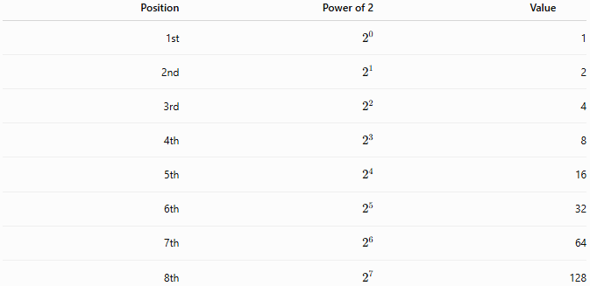
Position | Power of 2 | Value
1st | $$2^{0}$$ | 1
2nd | $$2^{1}$$ | 2
3rd | $$2^{2}$$ | 4
4th | $$2^{3}$$ | 8
5th | $$2^{4}$$ | 16
6th | $$2^{5}$$ | 32
7th | $$2^{6}$$ | 64
8th | $$2^{7}$$ | 128

General Representation
# Source: AI Source: Provided by: [Data Path: Persons Table -> ID Column: 1, Name_En Column: Motasem Essam] -> From: [ChatGPT] on [7/16/2026]
A binary numeral
$${\left(d_{n}d_{n-1}⋯d_{1}d_{0}\right)}_{2}$$
has the value
$$\boxed{\sum_{k=0}^{n}{d_{k}}2^{k}}$$
where each digit $d_{k}$is either 0 or 1.

Examples
# Source: AI Source: Provided by: [Data Path: Persons Table -> ID Column: 1, Name_En Column: Motasem Essam] -> From: [ChatGPT] on [7/16/2026]
Example 1
Binary number
$${1011}_{2}$$
Expanded form:
$$1×2^{3}+0×2^{2}+1×2^{1}+1×2^{0} \\ =8+0+2+1={11}_{10}$$

Example 2
Binary number
$${110101}_{2}$$
Expanded form:
$$1×32+1×16+0×8+1×4+0×2+1×1 \\ =32+16+4+1={53}_{10}$$

Binary Counting
# Source: AI Source: Provided by: [Data Path: Persons Table -> ID Column: 1, Name_En Column: Motasem Essam] -> From: [ChatGPT] on [7/16/2026]
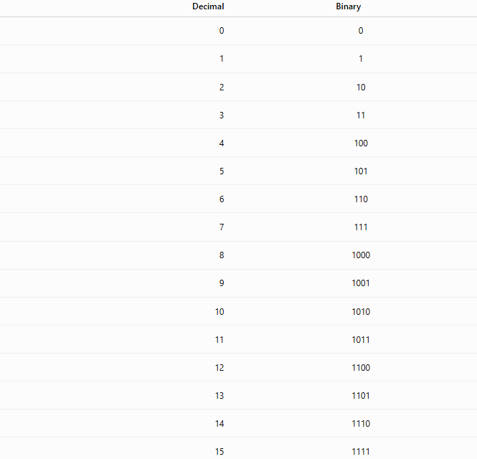
Decimal | Binary
0 | 0
1 | 1
2 | 10
3 | 11
4 | 100
5 | 101
6 | 110
7 | 111
8 | 1000
9 | 1001
10 | 1010
11 | 1011
12 | 1100
13 | 1101
14 | 1110
15 | 1111

Binary Place Value Chart
# Source: AI Source: Provided by: [Data Path: Persons Table -> ID Column: 1, Name_En Column: Motasem Essam] -> From: [ChatGPT] on [7/16/2026]
$$2^{7}$$ | $$2^{6}$$ | $$2^{5}$$ | $$2^{4}$$ | $$2^{3}$$ | $$2^{2}$$ | $$2^{1}$$ | $$2^{0}$$
128 | 64 | 32 | 16 | 8 | 4 | 2 | 1
Example:
$${10110110}_{2} \\ =128+32+16+4+2=182$$

Binary Fractions
# Source: AI Source: Provided by: [Data Path: Persons Table -> ID Column: 1, Name_En Column: Motasem Essam] -> From: [ChatGPT] on [7/16/2026]
Binary also represents fractional values.
Digits to the right of the binary point represent negative powers of 2.
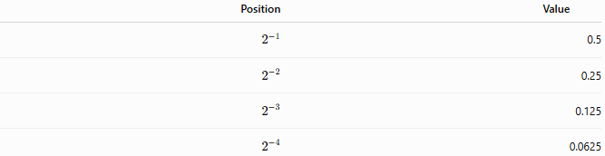
Position | Value
$$2^{-1}$$ | 0.5
$$2^{-2}$$ | 0.25
$$2^{-3}$$ | 0.125
$$2^{-4}$$ | 0.0625
Example:
$${101.101}_{2} \\ =4+1+0.5+0.125={5.625}_{10}$$

Characteristics
# Source: AI Source: Provided by: [Data Path: Persons Table -> ID Column: 1, Name_En Column: Motasem Essam] -> From: [ChatGPT] on [7/16/2026]
The binary numeral system:
- Uses only two digits.
- Is a positional numeral system.
- Uses powers of 2.
- Represents all integers and fractions.
- Is the foundation of digital computing.

Arithmetic Operations
# Source: AI Source: Provided by: [Data Path: Persons Table -> ID Column: 1, Name_En Column: Motasem Essam] -> From: [ChatGPT] on [7/16/2026]
Binary supports all standard arithmetic operations.
Addition
$$1+1={10}_{2}$$

Subtraction
$${10}_{2}-1_{2}=1_{2}$$

Multiplication
$${101}_{2}×{10}_{2}={1010}_{2}$$

Division
$${1100}_{2}÷{10}_{2}={110}_{2}$$

Applications
# Source: AI Source: Provided by: [Data Path: Persons Table -> ID Column: 1, Name_En Column: Motasem Essam] -> From: [ChatGPT] on [7/16/2026]
Binary is used in:
- Computer processors
- Digital electronics
- Logic circuits
- Programming
- Operating systems
- Data storage
- Networking
- Embedded systems
- Robotics
- Artificial Intelligence

Real-Life Applications
# Source: AI Source: Provided by: [Data Path: Persons Table -> ID Column: 1, Name_En Column: Motasem Essam] -> From: [ChatGPT] on [7/16/2026]
Binary is used for:
- CPU operations
- Memory storage
- Machine language
- Digital communication
- Internet protocols
- Mobile devices
- Game consoles
- Microcontrollers
- Sensors
- Digital signal processing

Advantages
# Source: AI Source: Provided by: [Data Path: Persons Table -> ID Column: 1, Name_En Column: Motasem Essam] -> From: [ChatGPT] on [7/16/2026]
The binary system:
- Is simple, using only two symbols.
- Matches electronic circuits with two stable states.
- Is reliable for digital hardware.
- Simplifies logic operations.
- Forms the basis of modern computing.

Disadvantages
# Source: AI Source: Provided by: [Data Path: Persons Table -> ID Column: 1, Name_En Column: Motasem Essam] -> From: [ChatGPT] on [7/16/2026]
The binary system:
- Requires more digits than decimal to represent the same value.
- Is less convenient for humans to read and write.
- Can produce long representations for large numbers.

Common Mistakes
# Source: AI Source: Provided by: [Data Path: Persons Table -> ID Column: 1, Name_En Column: Motasem Essam] -> From: [ChatGPT] on [7/16/2026]
- Reading binary numbers as decimal numbers.
- Forgetting that each position represents a power of 2.
- Using digits other than 0 and 1.
- Ignoring the base notation.

Key Points
# Source: AI Source: Provided by: [Data Path: Persons Table -> ID Column: 1, Name_En Column: Motasem Essam] -> From: [ChatGPT] on [7/16/2026]
- Binary is a Base 2 positional numeral system.
- It uses only 0 and 1.
- Each position represents a power of 2.
- It is the fundamental numeral system used by computers.
- Every binary number has an equivalent value in decimal.

Binary vs. Decimal
# Source: AI Source: Provided by: [Data Path: Persons Table -> ID Column: 1, Name_En Column: Motasem Essam] -> From: [ChatGPT] on [7/16/2026]
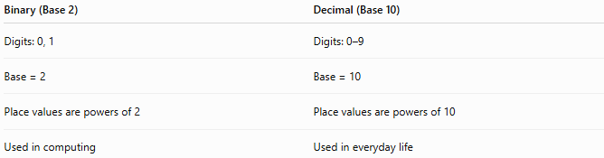
Binary (Base 2) | Decimal (Base 10)
Digits: 0, 1 | Digits: 0–9
Base = 2 | Base = 10
Place values are powers of 2 | Place values are powers of 10
Used in computing | Used in everyday life

Binary vs. Hexadecimal
# Source: AI Source: Provided by: [Data Path: Persons Table -> ID Column: 1, Name_En Column: Motasem Essam] -> From: [ChatGPT] on [7/16/2026]
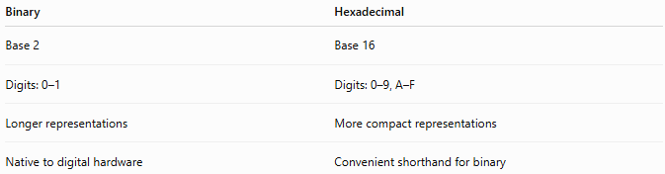
Binary | Hexadecimal
Base 2 | Base 16
Digits: 0–1 | Digits: 0–9, A–F
Longer representations | More compact representations
Native to digital hardware | Convenient shorthand for binary

Conclusion
# Source: AI Source: Provided by: [Data Path: Persons Table -> ID Column: 1, Name_En Column: Motasem Essam] -> From: [ChatGPT] on [7/16/2026]
The Binary Numeral System is a Base 2 positional numeral system that uses only the digits 0 and 1. Each digit's value depends on its position, with place values corresponding to powers of 2. Binary is the fundamental language of modern digital systems, forming the basis of computer hardware, software, communication networks, and digital electronics. Although less convenient for everyday human use than decimal, its simplicity and compatibility with electronic circuits make it indispensable in modern technology.

